Հավասար հայտարար ունեցող կոտորակների համեմատում
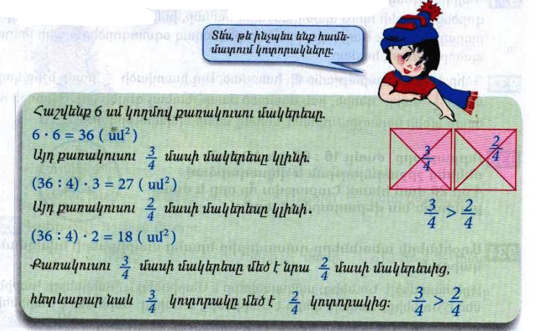
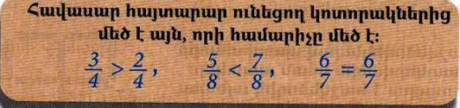
Դասարանական առաջադրանքներ
1․ Համեմատի՛ր
$$\frac{2}{5}<\frac{3}{5}$$

$$\frac{6}{17}> \frac{5}{17}$$

$$\frac{7}{123}=\frac{7}{123}$$

$$\frac{18}{19}= \frac{18}{19}$$
2․ Դասավորի՛ր կոտորակները․
Աճման կարգով
$$\frac{6}{17}, \frac{12}{17}, \frac{4}{17}, \frac{15}{17}, \frac{17}{17}, \frac{3}{17}$$
3/17, 4/17, 6/17, 12/17, 15/17, 17/17

3․Համեմատի՛ր
$$\frac{3}{5}մ <\frac{4}{5}մ$$
$$\frac{7}{10}կգ> \frac{4}{10}կգ$$
4․ 4500լ տարողությամբ ջրավազանը ամբողջությամբ լցված էր ջրով։ Այգեպանը այդ ջրի $\frac{2}{3}$ մասը օգտագործեց այգին ջրելու համար։ Քանի՞ լիտր ջուր մնաց ավազանում։(4500:3)x2=3000 4500-3000=1500
5․ Ավտոմեքենան պետք է անցներ 180կմ ճանապարհ։ Ճանապարհի $\frac{2}{3}$ մասն անցնելուց հետո քանի՞ կիլոմետր կմնա նրան դեռ անցնելու։(180:3)x2=120 180-120=60
6․ 1 ծորակից լցվում է 6000լ տարողությամբ ջրավազանի $\frac{1}{4}$ մասը։ Նույն ծորակից որքա՞ն ջուր կլցվի ջրավազանը 2 ժամում։(6000:4)x1=1500 1500x2=3000
7․ Ուրբաթ օրը՝ ժամը 16։00-ին, Աննան մեկնեց շրջագայության և վերադարձավ 4օր 20ժամ հետո։ Շաբաթվա ո՞ր օրը և ժամը քանիսի՞ն նա վերադարձավ տուն։ Չորեքշաբթի ժամը 12-ին
Տնային առաջադրանքներ
1․ Համեմատի՛ր
$$\frac{14}{18}< \frac{17}{18}$$

$$\frac{3}{7}<\frac{4}{7}$$
$$\frac{11}{28} >\frac{9}{28}$$

$$\frac{24}{143}> \frac{21}{143}$$

2․ Դասավորի՛ր կոտորակները․
Նվազման կարգով
$$\frac{31}{35}, \frac{17}{35}, \frac{4}{35}, \frac{22}{35} ,\frac{19}{35}, \frac{35}{35}$$
$\frac{35}{35}, \frac{31}{35}, \frac{22}{35}, \frac{19}{35}$, $\frac{17}{35}, \frac{4}{35}$

3․Համեմատի՛ր
$$\frac{3}{20}լ < \frac{6}{20}լ$$

$$\frac{2}{15}ժ < \frac{4}{15}ժ$$

4․ 4500լ տարողությամբ ջրավազանը ամբողջությամբ լցված էր ջրով։ Այգեպանը այդ ջրի $\frac{2}{3}$ մասը օգտագործեց այգին ջրելու համար։ Քանի՞ լիտր ջուր օգտագործեց այգեպանը այգին ջրելու համար։(4500:3)x2=3000
5․ Ջրավազանում կար 8000լ ջուր։ Այգին ջրելու համար պապին օգտագործեց այդ ջրի երեք քառորդ մասը։ Որքա՞ն ջուր մնաց ջրավազանում։ (8000:4)x3=6000 8000-6000=2000
6․ Մայրիկը գնեց 12կգ շաքարավազ։ Նա այդ շաքարավազի $\frac{1}{3}$ մասն օգտագործեց ծիրաանի հյութ պատրաստելու համար, իսկ մնացած մասը՝ ելակի մուրաբայի համար։ Մայրիկը որքա՞ն շաքարավազ օգտագործեց ելակի մուրաբա պատրաստելու համար։ (12:3)x1=4 12-4=8
7․ Երկու թվերի գումարը 650 է, իսկ տարբերությունը՝ 0։ Որո՞նք են այդ թվերը։ 650:2=325

