Մասերի համեմատումը
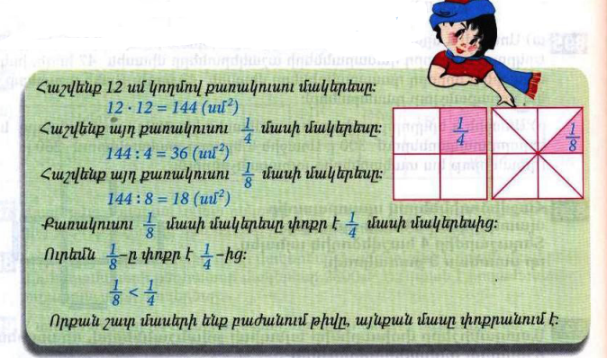
Դասարանական առաջադրանքներ
1․ Համեմատի՛ր։
$$\frac{1}{5}<\frac{1}{4}$$

$$\frac{1}{12}>\frac{1}{16}$$

$$\frac{1}{123}>\frac{1}{124}$$

$$\frac{1}{18}=\frac{1}{18}$$
2․ Թվերը դասավորիր
աճման կարգով․
$\frac{1}{16},\frac{1}{143},\frac{1}{9},\frac{1}{24},\frac{1}{142},\frac{1}{14}$
1/143, 1/142, 1/24, 1/16, 1/14, 1/9
3․ 8400լ տարողությամբ երկու ջրավազաններից լցված են առաջինի $\frac{1}{4}$մասը և երկրորդի $\frac{1}{5}$ մասը։ Ջրավազաններից որու՞մ ավելի շատ ջուր կա։ Որքա՞ն է նրանցում եղած ջրի քանակների տարբերությունը։ 8400:4=2100 8400:5=1680 2100-1680=420
4․ Ջրավազանում կար 1250լ ջուր, որը կազմում է նրա տարողության $\frac{1}{4}$մասը։ Որքա՞ն է այդ ջրավազանի տարողությամբ։ 5000
5․ Գտի՛ր անհայտ բաղադրիչը։
4928*+2142=7070
2014=3535-*1431
6․ Ավտեմեքենան առաջին օրը գնաց 80կմ/ժ արագությամբ 5ժ, իսկ երկրորդ օրը՝ 85կմ/ժ արագությամբ 3ժ։ Որքա՞ն ճանապարհ անցավ ավտոմեքենան այդ երկու օրում։ 80x5+85x3=400+255=655
7․ Շախմատի խմբակում կա 11 տղա և 5 աղջիկ: Ամեն ամիս խմբակին միանում է 1 տղա և 3 աղջիկ: Քանի՞ ամիս անց խմբակում տղաների և աղջիկների քանակը կհավասարվի: 3
8․Ջրավազանում ջուր կարող է լցվել 2 խողովակներից: Առաջին խողովակով մեկ ժամում լցվում է 120լ ջուր, իսկ երկրորդով՝ 140լ: Քանի՞ լիտր ջուր կլցվի ջրավազանում 5 ժամվա ընթացքում, եթե խողովակները միաժամանակ բացվեն:120x5+140x5=600+700=1300
Տնային առաջադրանքներ
1․ Համեմատի՛ր։
$$\frac{1}{7}>\frac{1}{9}$$

$$\frac{1}{28}<\frac{1}{16}$$

$$\frac{1}{143}=\frac{1}{143}$$

$$\frac{1}{19}>\frac{1}{27}$$
2․ Թվերը դասավորիր
նվազման կարգով
$$\frac{1}{12},\frac{1}{216},\frac{1}{8},\frac{1}{9},\frac{1}{220},\frac{1}{16}$$
1/8, 1/9, 1/12, 1/16, 1/216 1/220
3․ Մարդատար ավտոմեքենան 1 ժամում անցավ 240կմ երկարությամբ ճանապարհի $\frac{1}{3}$մասը, իսկ բեռնատարը՝ $\frac{1 }{4}$ մասը։ Ավտոմեքենաներից ո՞րն է 1 ժամում ավելի շատ ճանապարհ անցել։ Քանի՞ կիլոմետր ճանապարհ դեռ պիտի անցնի նրանցից յուրաքանչյուրը։ 240:3=80 240:4=60ավտոմեքենան 240-80 =160 բեռնատար 240-60=180
4․ Ջրավազանում կար 2400լ ջուր, որը կազմում է նրա տարողության $\frac{1}{3}$ մասը։ Դեռ որքա՞ն ջուր կարելի է լցնել այդ ջրավազանը։ 2400x3=6800 6800-2400=4400
5․ Գտի՛ր անհայտ բաղադրիչը։
21021=18018+*3003
40835*-8507=32328
6․ Երբ Հայկն իր գումարից 150դրամ տվեց Արային և 250դրամ՝ Գագիկին, նրանց ունեցած գումարները հավասարվեցին։ Որքա՞ն դրամ ուներ տղաներից յուրաքանչյուրը, եթե նրանք միասին ունեին 2400դրամ։ 1200 +650+550=2400

